National Collegiate Landscape Competition 2025
Computer Aided Landscape Design Competition

Note: Students will be provided a base plan with Title Block in DynaSCAPE .dpd format, to be uploaded on their computer. This base plan will include the building outline with doors and windows, existing elements to be kept, and simple grading information. Students will also be provided with photographs of the site and a PDF Base Plan that can be used for reference and for sketching.
Drawing Requirements/Tips:
- Important! Step # 1: Before starting the design, type in your student ID# in the bottom corner of the title block. This can be done by deleting the 00000000 number and using the insert text tool or by using [Crtl] + left-click to edit the exiting ‘00000000’ text. Important Note: Drawings not identified by Student ID # will be disqualified.
- Base Plan Info: Existing lines for existing elements and text can be erased or placed on the Temp layer. Grade layer can be turned off.
- Layers: Use appropriate DynaSCAPE layers for drawing design elements to achieve the correct line weights on printout.
- Symbols: Use appropriate symbols for plant material. Plant material is to be shown at full mature size (shrubs and small trees) and at about ¾ mature size (large trees).
- Labeling Plants: Label plant materials with generic names (i.e. ‘Large Deciduous Shade Tree’, ‘Large Conifer’, ‘Large Palm’, ‘Medium Evergreen Shrub’, ‘Low Perennial’, ‘Med Ornamental Grass’, ‘Groundcover’, ‘Annuals’, etc. or use the softscape labeling tool in Dynascape.
- Plant List: A plant list/table or quantification of plants is not required.
- Labeling Hardscapes: Hardscape labels will be generic as well (i.e. ‘Paving Stone Patio’, or ‘Pattern Concrete Walkway’, etc.)
- Patterns: Use appropriate patterns for hardscape materials (adjust pattern scale as needed).
- Printing: Drawings will be judged based on PDF and .dpd (Dynascape drawing) formats of your project. Judges will NOT be printing the drawings.
- Tie breaker: Time the drawing was last saved will be the tie breaker – the time stamp on the file will be recorded by the judges if needed.
- SUBMIT YOUR FILES AT THE END!. Upload both PDF and DPD files when you are finished.
Please ask for assistance if you require help with this process.

- Save your drawing often to avoid any chance of lost work!

Competition Assignment Goals and Objectives:

Goal: Thursday evening is allotted for students to prepare their designs. They may bring in their sketch to the competition prior to opening the Dynascape Program in the lab. Create a finished landscape concept plan with labels. (Time: 1hour and 50 minutes) Note: 1 hour and 50 minutes is the time to be spent on Dynascape and will be audited so keep the drawing .DPD closed until you are ready to transpose your concept on Dynascape.
1. Base plan drawing for the competition will be provided on your computer with Title Block on a 24”x18” (Arch C) sheet at a scale of 1”= 4’-0” (1/4” = 1’-0”)
2. The clients, Mr. & Mrs. Nichols are ready for a whole new landscape renovation. They are a couple with double income and no children. The wife recently received inheritance money and would like to spend it on her garden as a tribute to her late mother.
3. They would like an entire new backyard Landscape Installation. The only elements that must stay are the following: existing concrete terrace, and the AC unit in the backyard.
4. The couple would like to have a patio or deck in the backyard as well they require a main walkway to the garage. This is their main entrance as they park their vehicle in the garage and enter their home through the backyard most of the time.
5. A new fence must be designed and built on both sides in the backyard. A gate is needed to enter the backyard from the public laneway.
6. The existing grades have been indicated on the Base Plan and require steps where needed.
7. One primary objective with the new landscape installation is to remove the grass while creating a lush functional backyard.
8. The clients have had a series of flooding in their basement and need the landscape design to provide some solutions, so this doesn’t occur in the future.
9. The clients want the following to be considered in the design:
• New deck/patio
• area to barbeque
• Privacy from laneway and neighbors
• herb garden

• multi-seasonal gardens
• a place for a sculpture or water feature
- Solution to water problems

- Area to store garden tools and seasonal pots

• The key to success for this design is to keep things simple!

SITE PHOTOS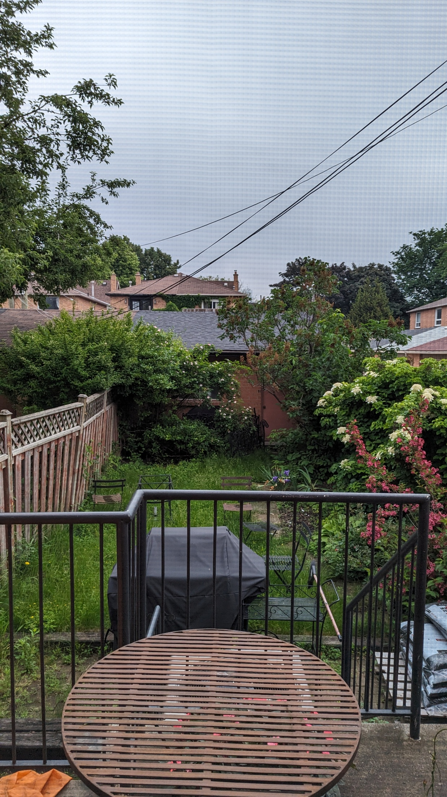
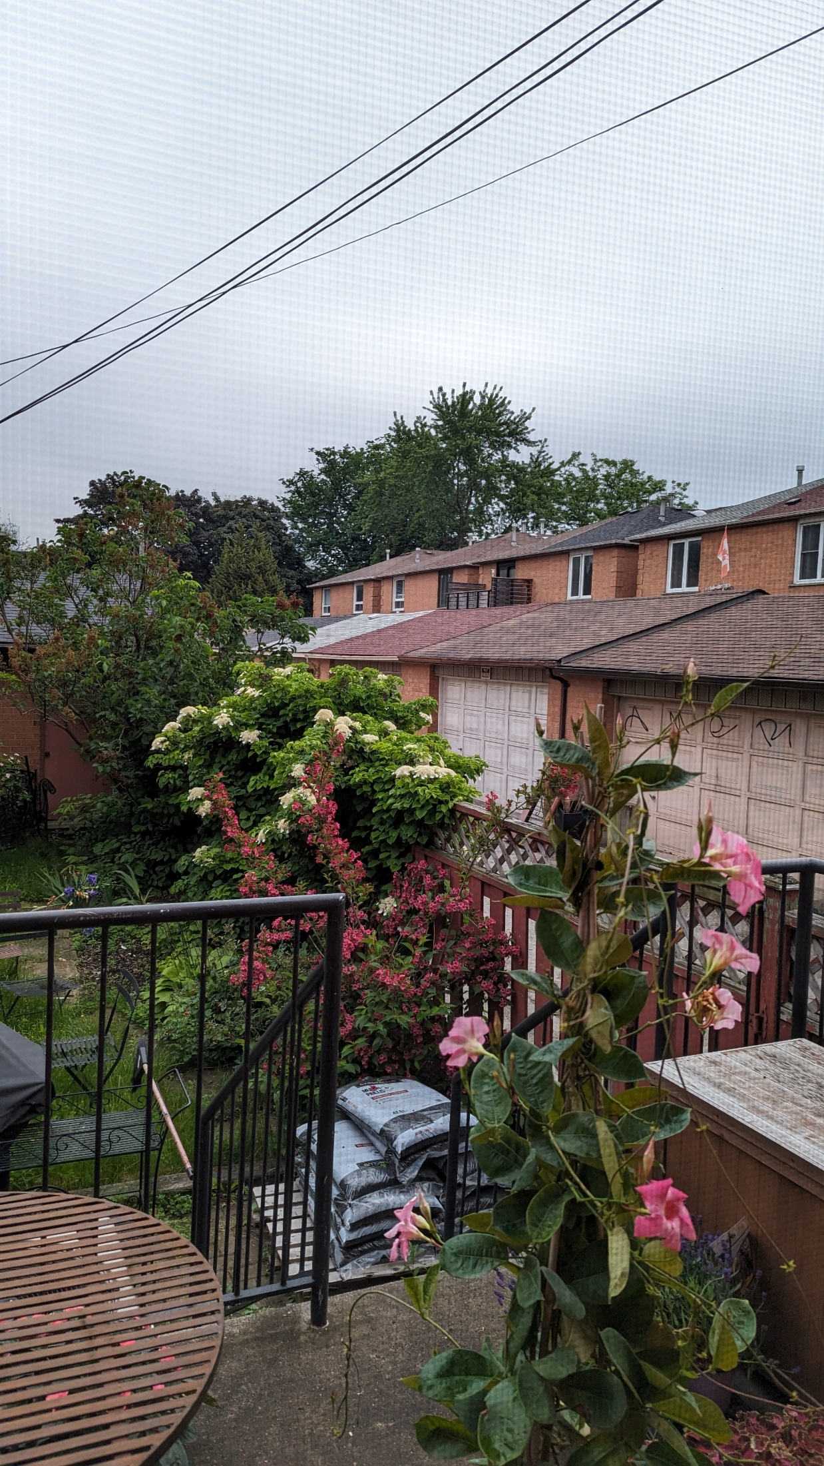
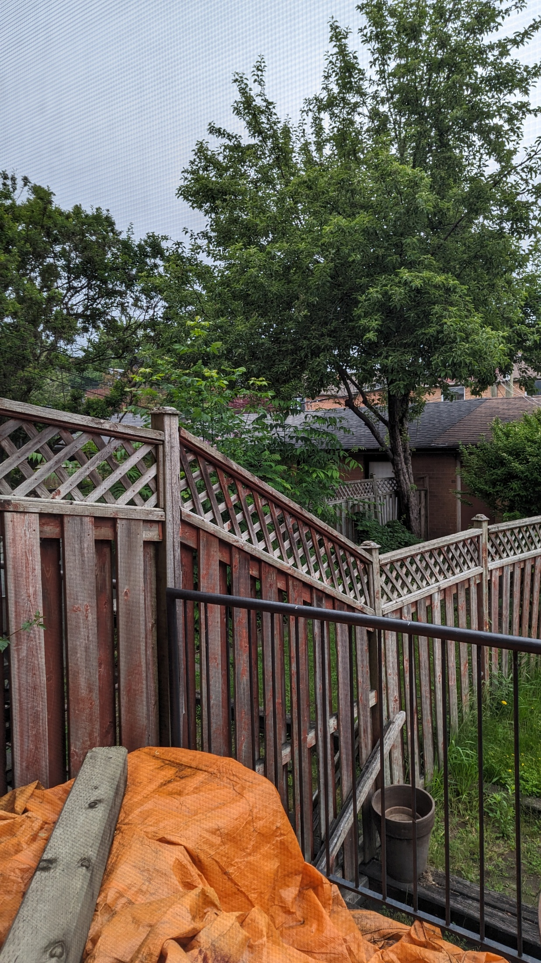

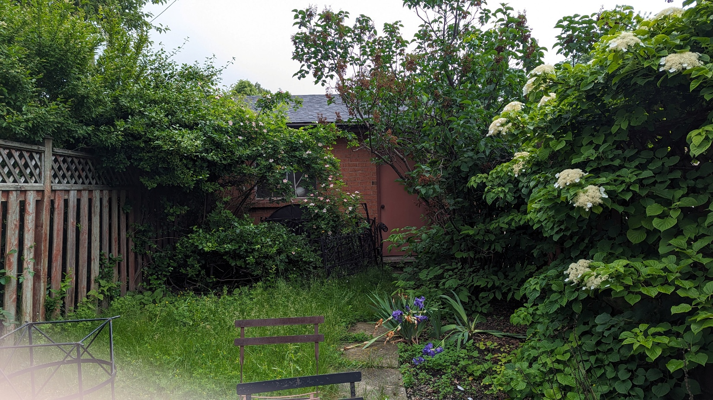

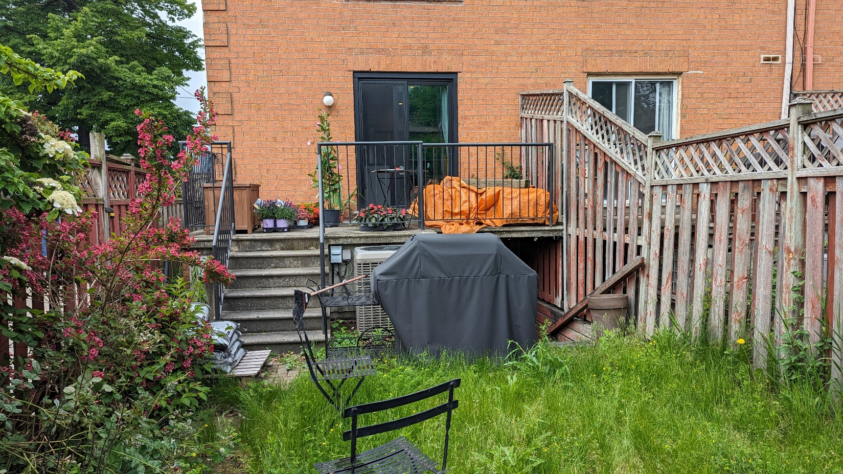

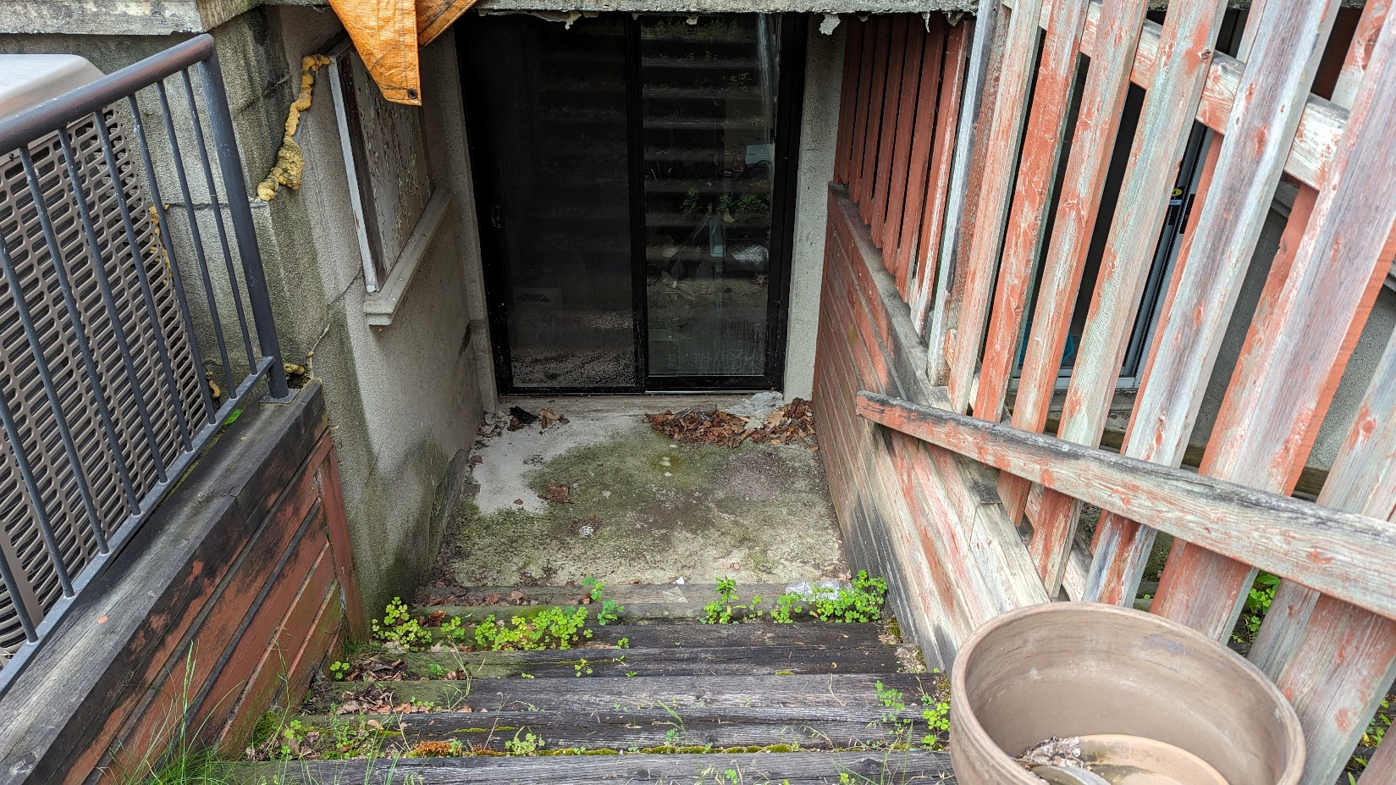

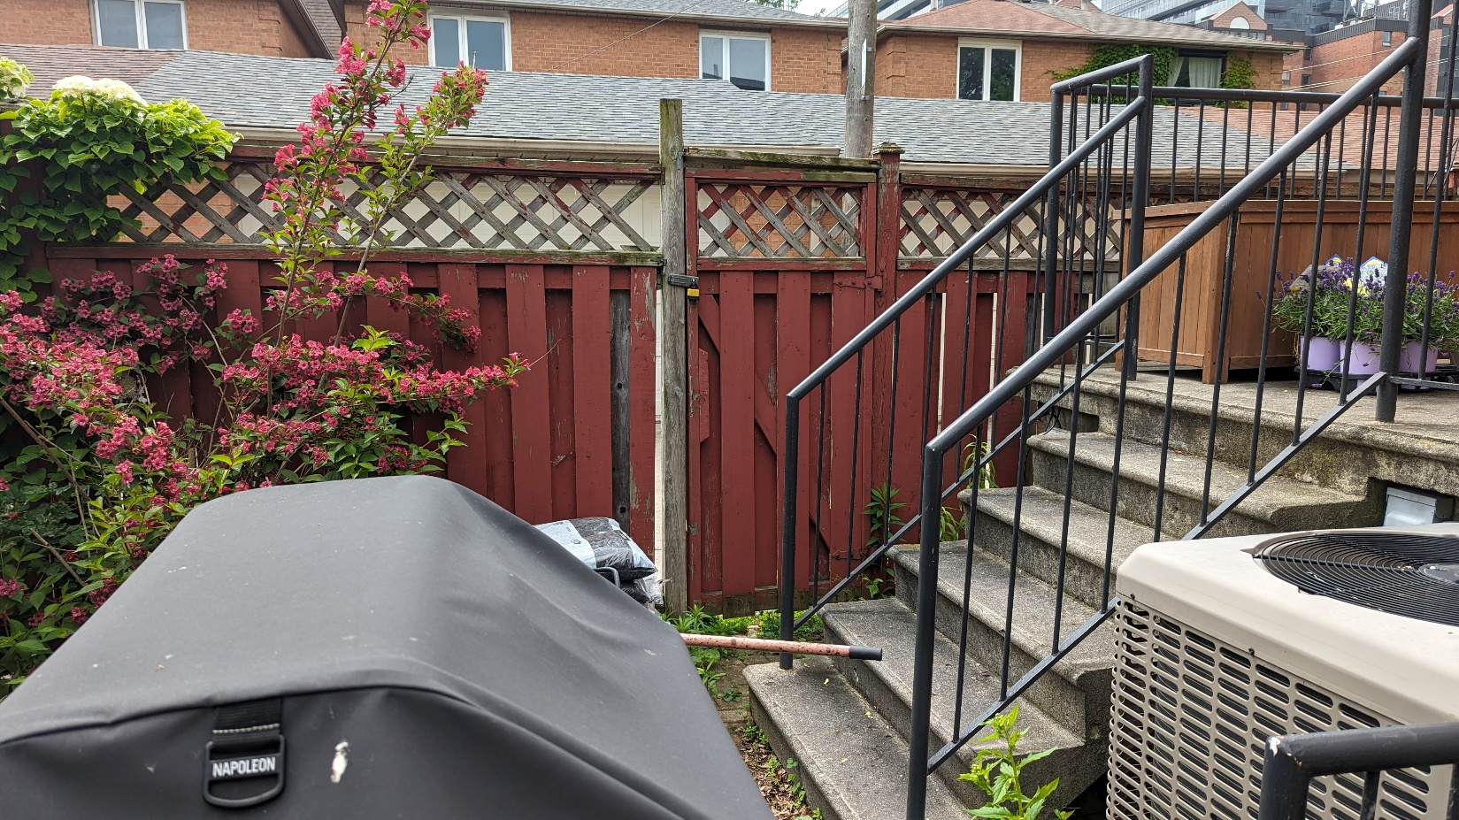

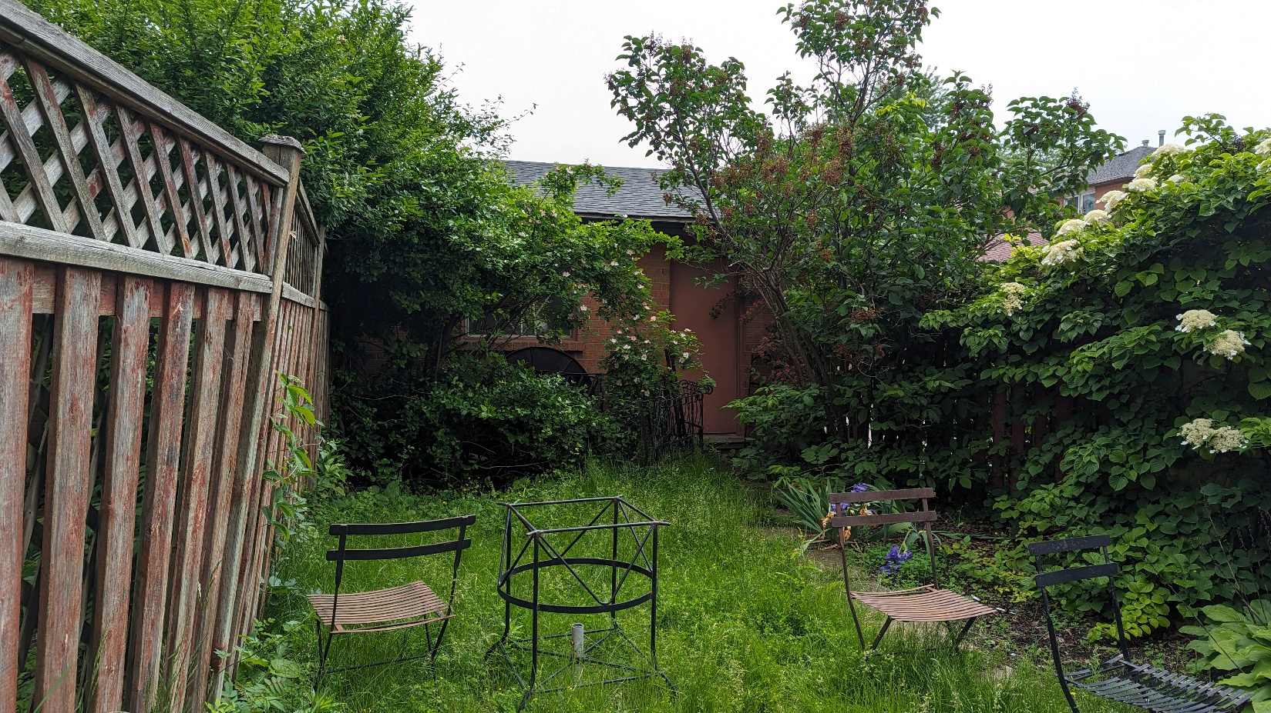

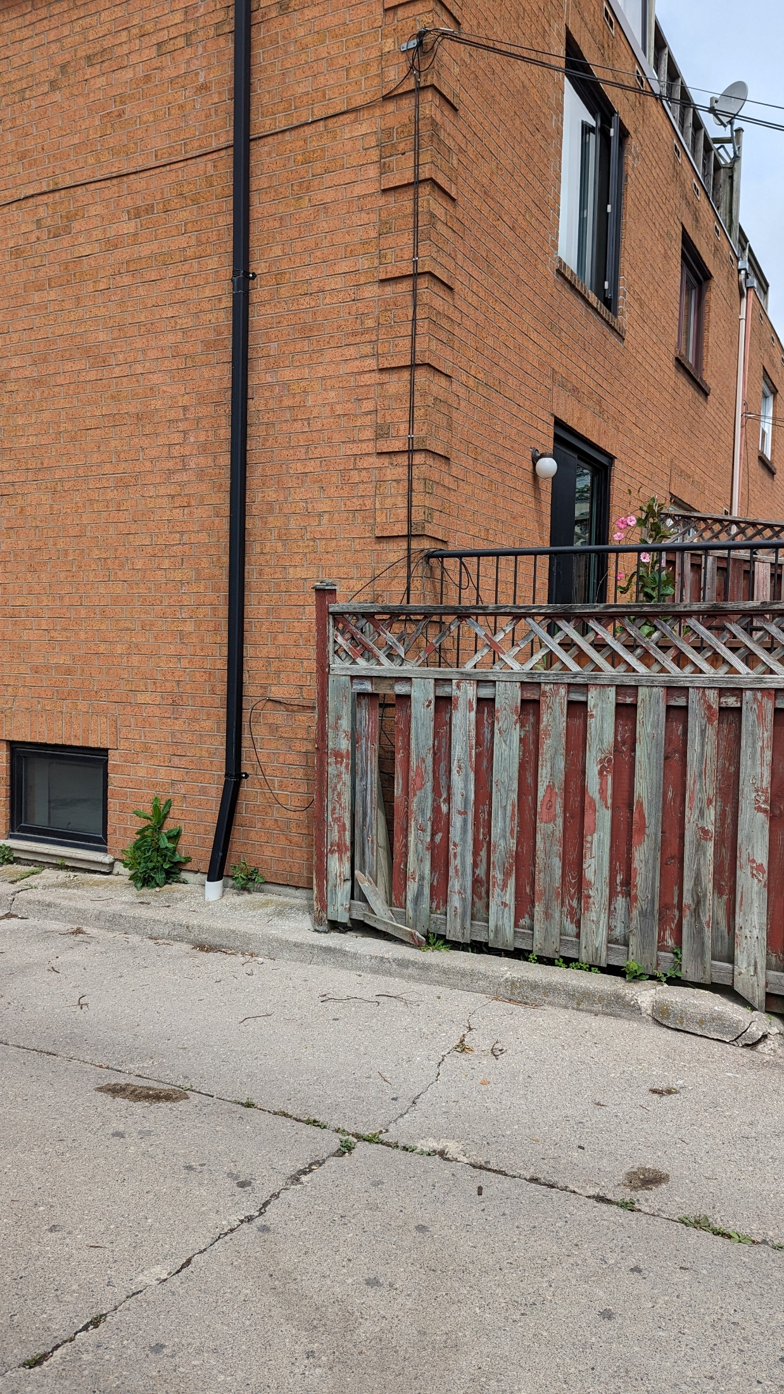
BASE PLAN